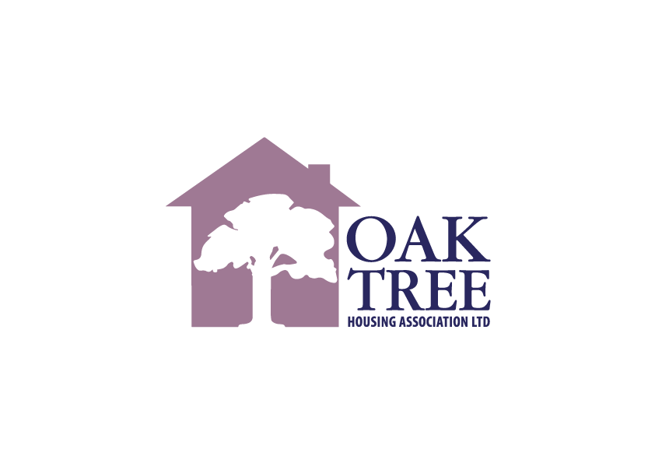

Scottish Housing Regulator Landlord Report 2023-24

The Scottish Housing Regulator has advised that they no longer produce a document version of Landlord Reports and instead customers of landlords can view the SHR’s Landlord Reports by visiting the SHR website.

If you wish to do this, please go to the following section of the SHR website and choose the landlord you want to review

www.housingregulator.gov.scot/landlord-performance/landlords

Once you choose the landlord you want, for example, Oak Tree, scroll down the page and you will see a tab labelled Landlord Report. On this webpage you will also see a box titled Compare this landlord to others – this is a comparison tool that you can use to compare up to 5 landlords.

The direct SHR web links for Oak Tree are as given below.

https://www.housingregulator.gov.scot/landlord-performance/landlords/oak-tree-housing-association-ltd

www.housingregulator.gov.scot/comparison-tool?landlord=2556

