Lead Housekeeper
(Part-time)
Oak Tree Housing Association
40 West Stewart Street, Greenock, PA15 1SH
Tel: 01475 807000

www.oaktreeha.org.uk
Our Vision
Building Better Futures

Our Values
Leadership
Accepting accountability and balancing vision with execution, leading by example and encouraging and developing the staff team to be the best they can be.

Customer Focus
When developing and providing our services, our tenants’ and other customers’ needs come first.

Team Working
By working together we develop our flexibility and resilience to ensure we provide a best value service to our tenants and customers.

Communication
Our communication is effective, accurate, up-to-date and easy to understand.

Respect
We treat our tenants, other customers and each other with respect and dignity at all times.

Integrity
Openness, honesty, transparency and trust are at the core of all that we do.

Index

Page

Job Description 3
Person Specification 6
Summary of Main Conditions 7
Key Dates 9
OTHA History 10
Committee & Staffing Structure 11

Job Description

JOB TITLE: Lead Housekeeper (Part-time)
RESPONSIBLE TO: Corporate Services & Admin Supervisor
GRADE: EVH Grade TAS2
DATE REVIEWED: December 2024
_________________________________________________________________________
1.0 Main Objectives of the post:
1.1 To ensure that our West Stewart Street premises are cleaned and maintained to the highest standard.
1.2 To assist with overseeing housekeeping operations.

2.0 Accountability:
2.1 To the Corporate Services & Admin Supervisor on a day-to-day basis & to the Senior Compliance and Governance Officer.

3.0 Duties and Responsibilities:

3.1 Cleaning:
3.1.1 To support the organisation with housekeeping duties and compliance with company standards.
3.1.2 To deliver the highest level of cleaning service within the areas of responsibility including the meeting rooms, offices, kitchen areas and bathroom areas.
3.1.3 Cleaning of carpeted and uncarpeted surfaces - floors, stairs, lifts, and other areas – with brushes, vacuum cleaners, steam cleaners and mops.
3.1.4 Periodic deep cleaning of these areas, including the use of carpet- and floor-cleaning equipment such as shampooers and floor polishers.
3.1.5 Cleaning of toilet facilities (toilets, shower, sinks, mirrors, floors, etc.) and replacing consumable products.
3.1.6 Cleaning and sanitization of tables, chairs, drinking fountains (excluding water dispensing machines), door handles, and other high-use areas.
3.1.7 Ensuring the dishwashers are switched on and emptied each evening.
3.1.8 Emptying of office waste bins and recycling material to appropriate locations

3.2 Stock Management:
3.2.1 Manage stock levels of cleaning materials.
3.2.2 Ensure cleaning materials are ordered via the Corporate Services & Admin Supervisor in a timely manner.

3.3 Checks & Audit:
3.3.1 Perform regular end of shift cleaning checks.
3.3.2 Conduct weekly thorough inspections to ensure cleanliness, hygiene, and safety standards are met, and take corrective actions as necessary.

3.4 Health & Safety:
3.41 To guarantee that cleaning products are used effectively, with instructions and health and safety procedures being always followed.
3.42 To ensure appropriate PPE is always used during working hours.
3.43 Ensure all chemical and cleaning solutions are used correctly.
3.44 Ensure a safe working environment in line with Health and Safety regulations and standards.
3.45 Report any dangers, near misses or hazards you encounter to the Corporate Services & Admin Supervisor.
3.46 To ensure all cleaning equipment is well maintained and safe for use, reporting of problems within the work areas or equipment.
3.47 To ensure Health and Safety and hygiene requirements are met.
3.48 Check windows/blinds closed, lights and machinery switched off - not computers.
3.49 Locking up the building/bin store and setting alarm each evening.
3.50 Ensure lone working procedures are followed (when applicable)

3.5 Staff Supervision:
3.5.1 To organise and plan workload for both you and your team member on a weekly basis.
3.5.2 Monitoring performance, time keeping and escalating concerns to the Corporate Services & Admin Supervisor.

4.0 General:
4.1 Liaise effectively with staff in other sections to maximise performance and enhance service delivery.
4.2 Assist in the implementation of the Associations’ Equal Opportunity and Diversity Policy and action plan as necessary.
4.3 Promote and uphold the Associations’ commitment to diversity and equal opportunities in the decision and provision of services, in the procurement of services and in all policies procedures, activities and conduct.
4.4 Attend training courses, seminars, and conferences, as required.
4.5 Promote and operate in line with OTHA’s workplace values, Leadership, Team Working, Integrity, Customer Focus, Respect & Communication.
4.6 Carry out other specific tasks, as instructed by the Corporate Services & Admin Supervisor, Senior Compliance and Governance Officer and/or Management Team, commensurate with the Lead Houskeeper grade.

Person Specification

Skills\Knowledge\Experience | Essential | Desirable
Previous experience in a similar role.
Excellent communication skills (both written and oral), with the ability to communicate clearly and give instructions.
Knowledge of cleaning products, equipment, and techniques.
Experience in staff supervision.
Able to organise and coordinate the work of yourself and others.
Ability to work well under pressure.
Ability to work on own initiative and as part of a team.
Ability to effectively manage a varied workload and to work to deadlines
Excellent organisational skills.
Knowledge of the General Data Protection Regulation.
Qualifications | Essential | Desirable
O’Grades, Standard Grades, Higher Grades or Equivalent
Practical training certificates in cleaning & health & safety at work.
Knowledge of health & safety regulations, (e.g.) COSHH
Personal Qualities | Essential | Desirable
Pro-active and solution focussed.
Flexible & reliable.
Trustworthy.
Open minded and inclusive.
Commitment to continuous improvement and quality in all aspects of work.
Strong commitment to maintaining highest standards of cleanliness.
Observant with excellent attention to detail.
Able to demonstrate an understanding and commitment to Equalities and the willingness to work in accordance with existing Policies and Codes of Practice

Summary of Main Conditions

Oak Tree Housing Association is a member of Employers in Voluntary Housing (EVH) and the terms and conditions for this post follow the EVH terms. A summary of some of the principal areas are as follows:

Salary Scale:
The current salary scale for this post is EVH Grade TAS2: £22,696.00 per annum (pro-rata).
The salary is paid by direct credit transfer monthly, normally on 23rd of each month.

Contract Type:
Part-time, permanent.

Hours of Work:
Normal hours of work are 10 hours per week, worked over 5 days, Monday to Friday.

- Monday to Thursday: 5pm to 7pm
- Friday’s: 2:30pm to 4:30pm

*Please note the office is open to 6pm on a Tuesday and closes at 4pm on a Friday.

Holiday Entitlement:
25 days annual leave and 15 days public holidays per annum (pro-rata).

Place of Work:
Oak Tree Housing Association, 40 West Stewart Street, Greenock.

Pension:
Oak Tree Housing Association is a member of the Scottish Housing Association’s Pension Scheme. Subject to terms of the scheme, we offer a defined Contribution scheme, with the option of an employee contribution of minimum 3% - 16%, with the OTHA contribution being 12%. Please note that life cover is included in the employer contribution.

Notice Period:
By employee: 1 month
By OTHA:
(i) continuous service under 5 complete years ~ 4 weeks.
(ii) continuous service of 5 years and over ~ 1 week for each complete year of service, up to a maximum of 12 weeks.

Additional Information:
OTHA currently offers an excellent working environment, staff onsite car parking, staff health checks (at 2 yearly intervals), annual staff teambuilding day, free fruit for staff delivered weekly and discounted membership to Inverclyde Leisure.

This summary is for general guidance of applicants and will not form part of the contract of employment.

Any offer of employment will be subject to the receipt of two satisfactory references.

Key Dates

Closing Date for Applications: | 5pm on Monday 13th January 2025
Interviews: | Friday 17th January 2025

OTHA History

Oak Tree Housing Association has a track record of developing and managing good quality homes in Inverclyde and has a high-performance culture, focussed on service delivery which is driven by increased involvement from tenants and residents in the decision-making process.
The Association owns and manages 1820 houses throughout Inverclyde and provides services for over 1,200 homeowners in Inverclyde.
We started developing in 1989 and since then, we have successfully completed over 60 house-building projects. The total investment value of these projects is presently estimated at £148M. The programme has catered for a variety of tenures. At 83%, social housing is the largest tenure. However, the programme has also provided accommodation for low-cost home ownership and outright sale on a shared equity basis.
Work has involved refurbishment, conversion, new-build and demolition. Wider action involvement was also significant in the development of a community centre in the Branchton Social Inclusion Partnership area. In fact, the regeneration of previously designated Social Inclusion Partnership areas had been the main focus of the Associations development activities in recent years. Development of these areas placed much emphasis on sustainability, energy efficiency and community involvement and the work that has been carried out in Branchton, Wren Road and Grieve Road is a credit to the Association and our development partners. This has helped to provide sustainable energy efficient affordable homes for 240 tenants and sharing owners in these areas.
Past achievements include the refurbishment of 57 closes in the West Station and Town Centre areas of Greenock. New-build which accounts for over 68% of the Associations total development programme has, over the years, provided a healthy mix of flats, and cottages.
In addition, a number of special needs facilities have been provided and these have helped people with learning disabilities to live a healthy life in the local community rather than remain in hospital care. The Association also built a Woman's Aid Refuge and this has been a great asset for the community in helping to address domestic abuse issues.
The last project completed by the Association was a 71 unit new-build development as part of a larger development of 198 homes with the Link Group. The units were handed over to Oak Tree as a turnkey project and all units at Bunston Grove have been well received by tenants.

Committee & Staffing Structure

The Association is managed by a Committee of Management made up of 12 members (maximum of 15) and operates currently through two sub-committees as follows:

Management Committee

Finance, Staffing & General Purposes Sub Committee
Housing & Technical Services Sub Committee

All sub-committees meet on a quarterly basis.

Staffing Structure

Information on our staffing structure can be found here:

https://oaktreeha.org.uk/Staff/

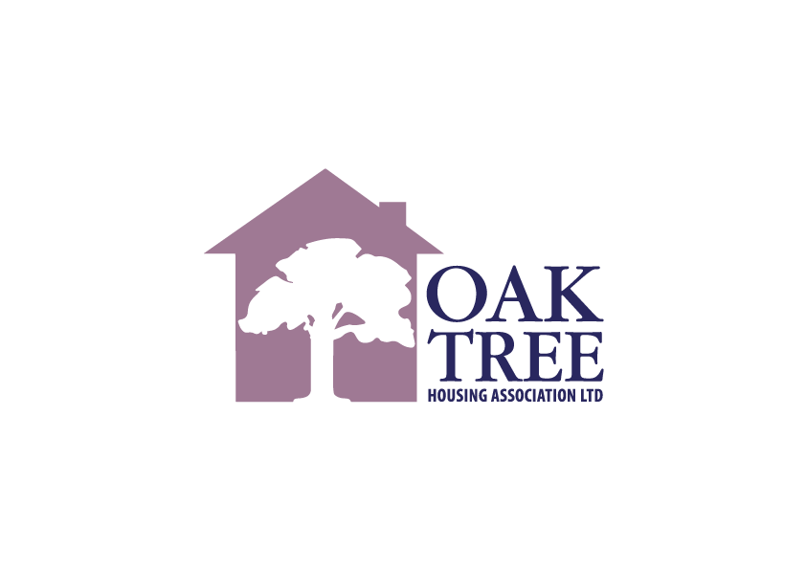

Oak Tree Housing Association
40 West Stewart Street, Greenock, PA15 1SH
Tel: 01475 807 000

www.oaktreeha.org.uk

